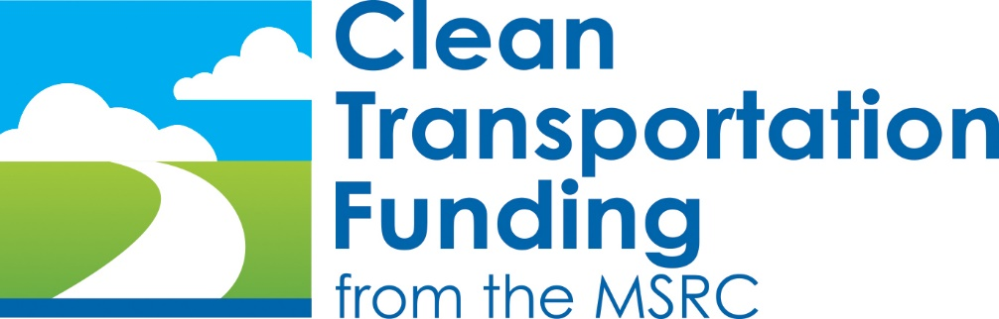

Program Opportunity Notice for the
Implementation of Hydrogen Refueling Stations
In the South Coast Air District

Hydrogen Infrastructure Partnership Program

PON2018-02

April 6, 2018

Section I: Introduction

For the past 27 years, the Mobile Source Air Pollution Reduction Review Committee (MSRC) has been a recognized leader in the implementation of alternative fuel infrastructure in the South Coast AQMD region. Infrastructure is the essential, enabling component of any alternative fuel vehicle strategy, and the MSRC has historically assumed the role of providing infrastructure funding to support low emission vehicle deployment programs, including but not limited to the Carl Moyer Program and the South Coast AQMD’s Fleet Rules. Without the availability of incentives to offset the cost of alternative fuel infrastructure, it is less likely that programs such as Moyer and the AQMD Fleet Rules would have been able to achieve the significant reductions in air pollution and quality of life improvements that have taken place over the past two decades. The MSRC takes pride in its role as a strategic partner in these important air quality improvement programs.

With the State and SCAQMD emphasis on transitioning vehicles to zero and near-zero emissions, the MSRC’s role in providing funding for enabling infrastructure has expanded to include fuels such as renewable natural gas and electric vehicle support equipment (EVSE). With the introduction of consumer-oriented zero emission fuel cell passenger vehicles, and the development and demonstration of fuel cell drayage trucks to support zero emission goods movement, the MSRC is further expanding its available funding to support implementation of hydrogen vehicle refueling infrastructure in the South Coast AQMD region.

The MSRC recognizes that the lead agencies for the implementation of hydrogen refueling stations are, at the state level, the California Energy Commission, and locally the South Coast AQMD. Through its Alternative and Renewable Fuel and Vehicle Technology Program, the California Energy Commission (Energy Commission) have developed unique expertise pertaining to the selection, management, and oversight of hydrogen refueling station implementation. The South Coast AQMD also has extensive hydrogen infrastructure experience as well as local insight into hydrogen refueling station needs and opportunities. As such, the MSRC seeks to partner with the Energy Commission, the South Coast AQMD, and other public and private stakeholders, to expand the availability of hydrogen refueling as a means to accelerate the deployment of large numbers of zero emission hydrogen vehicles.

Section II: Program Opportunity Notice Overview

This Program Opportunity Notice (PON) seeks to expand the availability of hydrogen refueling infrastructure in the South Coast AQMD region by making available a source of co-funding that can be accessed by the MSRC’s strategic partners. The intent is to provide funding that can be used to improve the financial viability of a candidate hydrogen refueling station that has already undergone vetting by the Energy Commission or South Coast AQMD, or is being proposed by a public agency or industry stakeholder that will undergo evaluation by the MSRC, Energy Commission, or South Coast AQMD. The goal is to have this funding source readily available so it can be tapped by our strategic partners during and within the course of their regular procurement processes.
To this end, the MSRC has allocated Three Million Dollars ($3,000,000) in Clean Transportation Funding™ from its FY 2016-’18 Work Program for the MSRC’s Hydrogen Infrastructure Partnership Program. This is an initial funding allocation; the MSRC reserves the right to increase the funding available under this PON by allocating additional funds from either the FY 2016-’18 Discretionary Fund or a future Work Program.

The MSRC has established additional, specific objectives for the Hydrogen Infrastructure Partnership Program:
- Ensure the Program is geographically broad based, with the goal of having at least one (1) hydrogen station emplaced within each county that comprises the South Coast AQMD. To ensure broad geographic participation, the MSRC is establishing a geographic funding minimum in an amount of $500,000 per county;
- Provide adequate time for technologically sophisticated refueling station designs and potentially complex station implementation partnerships to be forged. The MSRC recognizes that hydrogen refueling infrastructure is relatively expensive, poses unique technical challenges, and often involves the participation of multiple stakeholders. These stakeholders may include hydrogen fuel providers, automobile manufacturers, property owners, as well as the state and local funding agencies. To ensure sufficient time is available to allow all necessary project elements to be fully developed, the MSRC is establishing an approximately 24-month period for the submittal of hydrogen station concepts and funding requests under this PON. This submittal period can be extended at the discretion of the MSRC.

Section III: Hydrogen Infrastructure Partnership Program – How to Participate

Participation in the MSRC Hydrogen Infrastructure Partnership Program is designed to minimize upfront paperwork so as to not to unduly burden participating agencies or entities.
MSRC Public Agency Infrastructure Partners
Public agencies, specifically the Energy Commission, South Coast AQMD, and California Air Resources Board, which are established MSRC infrastructure partners, are asked to submit a concise Hydrogen Refueling Station Concept Description to initiate the PON process. The Concept Description should include:
- The hydrogen refueling station’s proposed location;
- Anticipated user base and/or fuel throughput (i.e., anchor tenants);
- Project participants, including refueling station sponsor;
- Implementation schedule;
- Station cost, including the existing funding shortfall;
- Requested MSRC funding amount.
If available, it is requested that the Concept Description include as an attachment a copy of the original station proposal submitted to the Energy Commission, South Coast AQMD, and/or Air Resources Board, as well as a summary of the proposal’s evaluation or scoring based on agency review.

Other Project Proponents
In addition, all public and private entities seeking to establish new or expanded hydrogen refueling infrastructure are eligible and encouraged to participate under this PON. Non-regulatory agency participants are asked to submit their Hydrogen Refueling Station Concept Descriptions in accordance with the following guidelines:
- Cover Letter that identifies the name of the individual or organization submitting the hydrogen station Concept Description, including but not limited to telephone and e-mail address of the contact person(s) for technical and contractual matters.
- A concisely written hydrogen refueling station technical description, including: a) technical specification; b) project location; c) station development participants, and d) anticipated user base and/or hydrogen fuel throughput.
- Project Schedule, including the timeframe for project implementation and any anticipated barriers to project completion.
- Estimated Project Cost, including total project cost, sources of match funding and other direct cost-sharing, and whether co-funding is secured or anticipated.

Section IV: Project Review & Funding Process

All hydrogen refueling station concepts will be reviewed by the MSRC’s Technical Advisory Committee/Infrastructure Subcommittee. Submittal of a Hydrogen Refueling Station Concept Description will result in one of the following three outcomes:

- A request by the MSRC for the submittal of a full proposal for possible sole-source funding consideration;
- Notification that a detailed Request for Proposals (RFP) will be issued at a later date;
- Notification that a Hydrogen Refueling Station Concept Description has been declined from further consideration.

Hydrogen refueling station proponents selected for MSRC funding will be required to enter into a contract with the South Coast AQMD on behalf of the MSRC. This contract will be the result of a negotiation between the MSRC, SCAQMD, and the hydrogen refueling station project lead entity. In cases where the South Coast AQMD is the project sponsor, the MSRC may elect to transfer funding using established interagency accounting practices. In all cases, projects must be approved by the MSRC and South Coast AQMD Governing Board prior to the execution of a contract or disbursement of MSRC funds.

The period of submittal under this PON closes on April 10, 2020, unless extended by the MSRC. Hydrogen Refueling Station Concept Descriptions should be sent via e-mail to:

Cynthia Ravenstein
MSRC Contracts Administrator
Cynthia@CleanTransportationFunding.org

If you have any questions regarding this Program Opportunity Notice, please direct inquiries to one of the following MSRC staff contacts:

- For General and Administrative Assistance, please contact:
Cynthia Ravenstein
MSRC Contracts Administrator
Phone: 909-396-3269
E-mail: Cynthia@CleanTransportationFunding.org

- For Technical Assistance, please contact:
Ray Gorski
MSRC Technical Advisor
Phone: 909-396-2479
E-mail: Ray@CleanTransportationFunding.org

In keeping with adopted policy and past practice, the MSRC reserves the right to reduce the total funding available and reallocate funds to other Work Program categories in the event hydrogen infrastructure funding requests total less than the amount allocated, or if projects are deemed non-meritorious. The MSRC also reserves the right to not fund any of the projects received, irrespective of the merits of the projects submitted for funding consideration.
The source of MSRC Clean Transportation Funding™ is motor vehicle registration fees collected by the California Department of Motor Vehicles (DMV) in accordance with the California Health and Safety Code. Thus, the availability of MSRC Clean Transportation Funding™ is contingent upon the timely receipt of funds from the DMV. Neither the MSRC nor South Coast AQMD can guarantee the collection of remittance of registration fees by the DMV.

